IMPURITY-INDUCED PHOSPHORESCENCE IN CARBAZOLE DERIVATIVES

PIEMAISĪJUMU RADĪTA FOSFORESCENCE KARBAZOLA ATVASINĀJUMOS
Artūrs Mazarevics^{1,2}, Kaspars Leduskrasts¹, Edgars Suna^{1,2}
¹ Latvian Institute of Organic Synthesis, Aizkraukles iela 21, Riga, Latvia
² University of Latvia, Faculty of Chemistry, Jelgavas iela 1, Riga, Latvia
e-mail: arturs.mazarevics@osi.lv

Phosphorescence is a type of luminescence in which the emission lifetime is longer than 1µs. Usually, phosphorescence is exhibited by metal containing compounds, but the high toxicity and manufacturing costs as well as low stability limits the use of such materials. To overcome these drawbacks purely organic phosphorescent materials recently have become popular because of their biocompatibility, low cost, and limitless design possibilities.¹

Carbazole 1 subunit is a widely used moiety in the field of purely organic phosphorescence, but in 2021 it was shown that commercially available carbazole has an isomeric impurity – benzo[f]indole 2, which is responsible for the phosphorescence obtained from carbazole containing luminophores.² Herein, we report the synthesis of carbazoles 3b–7b in which the carbazole ring was formed through Clauson-Kaas cyclization, thus avoiding commercial impurities. Initially, carbazoles 3b–7b showed phosphorescence, however, after laborious purification, it disappeared. This led us to believe, that a byproduct in the Clauson-Kaas cyclization was responsible for the phosphorescence. Therefore, we created a series of two component systems, where carbazole derivatives 3b–7b were used as hosts and byproducts 3c–7c and 3d –7d as dopants. The two component systems where the indole derivatives 3c–7c were used as dopants, didn’t exhibit phosphorescence. Meanwhile employing benzo[b]carbazole derivatives 3d –7d as dopants resulted in an intense phosphorescence.

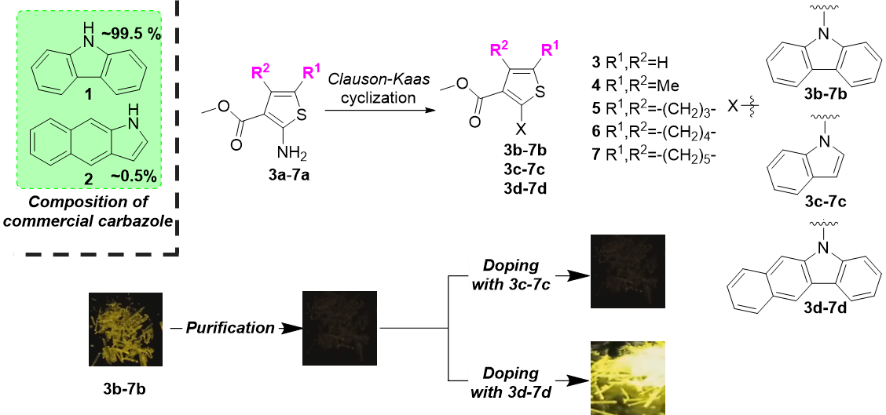
Fig. 1. Impurity-induced phosphorescence in carbazoles 3b–7b

References
[1] Zhao, W.; He, Z.; Lam, J. W. Y.; Peng, Q.; Ma, H.; Shuai, Z.; Bai, G.; Hao, J.; Tang, B. Z. Chem 2016, 1, 592–602.
[2] Chen, C.; Chi, Z.; Chong, K. C.; Batsanov, A. S.; Yang, Z.; Mao, Z.; Yang, Z.; Liu, B. Nat. Mater. 2020, 20, 175–180.

