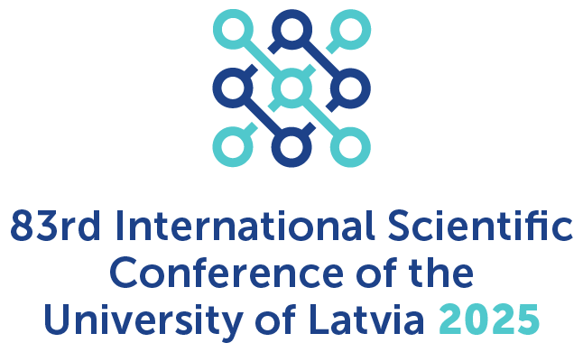 | Research Diversity in Action  Pētījumu daudzveidība praksē  Thursday, 30 January 2025, 10.00 AM,  MSTeams.
Programme

Chair: Prof. Gunta Roziņa
10.00–10.05 | Prof. Gunta Roziņa  Department of English Studies, Faculty of Humanities, University  of Latvia | Opening
10.05–10.15 | Prof. Indra Karapetjana  Prof. Gunta Roziņa  Department of English Studies, Faculty of Humanities, University  of Latvia | Nordplus project Teacher Research Literacy: Comparative Trajectories in the Nordic-Baltic Region NPHz’023/10004
10.15–10.25 | Prof. Gunta Roziņa  Prof. Indra Karapetjana  Department of English Studies, Faculty of Humanities, University  of Latvia | Erasmus+ KA2 project Mitigate the Impact of Fourth Industrial Revolution on Indian Society: Education Reform for Future and In-service School Teachers (EDUREFORM) 609699-EPP-1-2019-1-INEPPKA2-CBHE-JP
10.25–10.35 | Prof. Andrejs Veisbergs  Prof. Indra Karapetjana  Department of English Studies, Faculty of Humanities, University  of Latvia | State Research Programme project Latviešu valodas daudzveidība laikā un telpā/ Diversity of Latvian Language in Time and Space Nr. VPP-LETONIKA-2021/4-0003
10.35–10.45 | Prof. Andrejs Veisbergs  Department of English Studies, Faculty of Humanities, University  of Latvia | COST CA22126 - European Network On Lexical Innovation (ENEOLI)) 06/10/2023- 05/10/2027
10.45–10.55 | Assoc. prof. Vita Kalnbērziņa  Assoc. prof. Zigrīda Vinčela  Asst. prof. Antra Leine  Department of English Studies, Faculty of Humanities, University  of Latvia | Project Latvian Diaspora Identity Transformation: Text, Language, Digital Environment LU-BA-PA-2024/1-0019 The project is a part of: Project No 5.2.1.1.i.0/2/24/I/CFLA/007 "Internal and External Consolidation of the University of Latvia"
10.55–11.05 | Assoc. prof. Jana Kuzmina  Assoc. prof. Vita Kalnbērziņa  Assoc. prof. Zigrīda Vinčela  Asst. prof. Laura Karpinska  Lect. Margarita Spirida  Department of English Studies, Faculty of Humanities, University  of Latvia | Project Language Technology Initiative 2.3.1.1.i./0/1/22/I/CFLA/002 LU reģ. Nr. ESS2023/453 https://www.vti.lu.lv/
11.05–11.15 | Assoc. prof. Monta Farneste  Department of English Studies, Faculty of Humanities, University  of Latvia | UL Academic Development project Baltic Journal of English Language, Literature and Culture
11.15–11.25 | Prof. Gunta Ločmele  Lect. Svetlana Koroļova  Department of English Studies, Faculty of Humanities, University  of Latvia | The European Master's in Translation (EMT): student involvement and benefits
11.25–11.35 | Lect. Vineta Apse  Asst. prof. Laura Karpinska  Doctoral student Krisīna Korneliusa  Department of English Studies, Faculty of Humanities, University  of Latvia | Participation of the Department of English Studies in Researchers’ Night and other activities to popularise linguistics as a science
11.35–12.00 | Conclusions, discussions

