 | Research and Innovation programme Horizon Europe and Nordforsk call news and COST activities  Thursday, 14 February 2025, 10.00 AM,  Online, Zoom
Programme
Chair: Inga Sirante, Latvian Council of Science, Horizon Europe NCP senior experts

10.00–10.20 | Ingrida Lavrinovica, Latvian Council of Science, Horizon Europe NCP senior expert | Horizon Europe Cluster 4: Empowering Europe with Next-Generation Raw & Innovative Materials
10.20–10.40 | Janis Ancans, Latvian Council of Science, Horizon Europe NCP senior expert | Cluster Health and Mission Cancer participation opportunities
10.40–11.00 | Lasma Brenca/ Aiga Salmiņa, Latvian Council of Science, Horizon Europe NCP senior experts | Horizon Europe Cluster 6: Advancing Biotechnology for a Sustainable Future
11.00–11.20 | Liga Lice da Costa,  Latvian Council of Science, Horizon Europe NCP senior expert | Marie Skłodowska-Curie Actions: general overview and funding opportunities
11.20–11.40 | Lubova Tihomirova, Latvian Council of Science, Horizon Europe NCP senior expert | NordForsk funding opportunities for Baltic and Nordic countries
11.40–11.55 | Maija Bundule, LCS, International Research programmes Unit, Head of Unit | COST program. Opportunities and conditions
11.55-12.00 | Conclusions, discussions

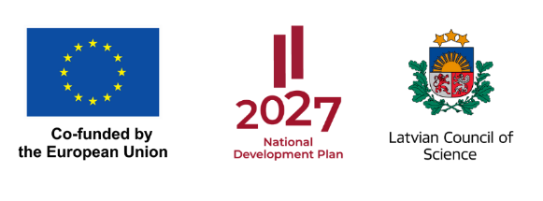
"Projekts 1.1.1.5/1/24/I/001 "Atbalsts Latvijas dalībai starptautiskās pētniecības un inovācijas programmās"

