 | 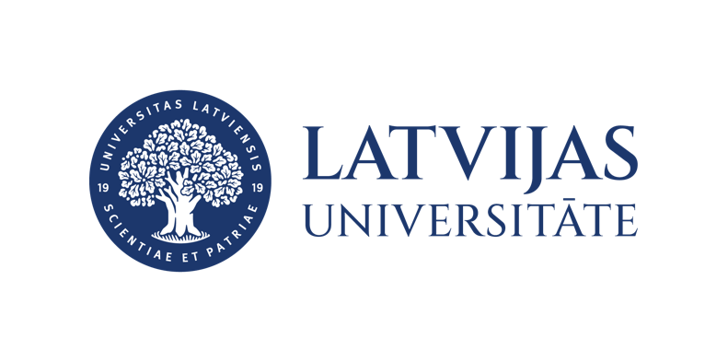

Mākslīgais intelekts, dati un sabiedrības uzticēšanās tehnoloģijām digitālajā valstī / Artificial Intelligence, Data, and Public Trust in Technologies in the Digital State
Trešdiena, 2026. gada 15. aprīlī, plkst. 09.00
Jelgavas iela 3, Rīga

Wednesday, 15 April 2026, 09:00
Jelgavas iela 3, Rīga

Programma | Programme

09.00–09.20 | Irēna Barkāne  University of Latvia  Latvijas Universitāte | ​Implementation of the EU Artificial Intelligence Act in Latvia and future policy directions for developing trustworthy AI
09.20–09.40 | Sandra Kalniņa  Tamāra Pīgozne  University of Latvia  Latvijas Universitāte | ​AI in Higher and Adult Education: Benefits, Risks, and Skill Transformation
09.40–10.00 | Juris Dzelme  University of Latvia  Latvijas Universitāte | ​ Human-AI interaction
10.00–10.20 | Anna Ansone  University of Latvia  Latvijas Universitāte | ​Technology Acceptance Models for Generative AI in Higher Education
10.30–11.00 | Kafijas pauze, diskusijas/Coffee break, discussions
11.00–11.20 | Līga Svempe  Riga Stradiņš University  Rīgas Stradiņa Universitāte | Liability and Legal Challenges in Digital Wellness
11.20–11.40 | Oskars Galanders  Tiesību efektivitātes un kvalitātes institūts  Institute for the Effectiveness and Quality of Law | ​Re-Engineering the State: IFR-Driven, Citizen-Chosen Autonomous Agents for Public Functions
 |  | ​

