 | 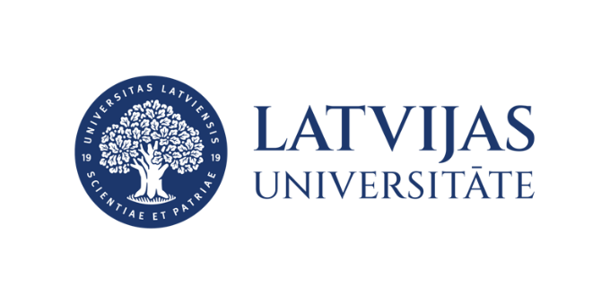
Multidisciplinary perspectives on climate change and environmental sustainability / Klimata pārmaiņas un vides ilgtspēja dažādās nozarēs un disciplīnās
Thursday, 16 April 2026, 8.00 a.m
House of Science,Jelgavas street 3, Riga

Programma | Programme
8:00 – 9:00 | Registration, technical check and poster set-up
 | Morning session. Chairs: Iveta Šteinberga/ Olga Sozinova
09.00–09.15 | Gaidis Klāvs  Institute of Electronics and Computer Science  Latvia | Analytical tools for assessing greenhouse gas emission reduction paths to achieve Latvia’s climate neutrality goal.
09.15–09.30 | Zanda Gailume-Zohara  Riga Stradins University  Latvia | Perception and implementation of environmental sustainability measures in Latvian state-sector hospitals
09.30–09.45  (remotely) | Franziska Zemmer  Fondazione Edmund Mach, Italy | Does the airborne pollen spectrum of alpine sites reflect local vegetation?
09.45–10.00 | Linards Klavins  University of Latvia  Latvia | Cascading valorisation of coniferous logging residues within a circular forestry biorefinery
10.00–10.15 | Evelina Niedrīte  University of Latvia  Latvia | A valorisation-based approach to invasive plant control: pellet fuel and biochar production
10.15–10.30 | Annija Danenberga  Latvia University of Life Sciences and Technologies, Latvia | Reframing peat soils in transboundary river basins as critical climate, hydro-environmental and socio-economical infrastructures
10.30–11.00 | Coffee break/ discussions/ poster session (4 posters)
11.00–12.30 | Plenary session. Chairs: Olga Sozinova/ Iveta Šteinberga
11.00–12.30 | Renārs Kairis | Sustainability Roadmap at the University of Latvia
11.00–12.30 | Olga Mutere | Evaluation of functional capacity and plastic-degrading potential of Bacillus spp. and other bacteria derived from the Getliņi landfill
12.30–13.30 | Lunch break (not sponsored)
 | Afternoon session. Chairs: Agrita Briede/ Iveta Šteinberga
13.30–13.45  (remotely) | Ksenia Jović  University of Novi Sad  Serbia | Airborne fungi in pannonian plain - assessment of different analytical approaches
13.45–14.00 | Vikija Kupča  University of Latvia  Latvia | Comparative analysis of source apportionment in urban and remote marine environments
14:00 – 14:15 | Oskars Kaļva  University of Latvia  Latvia | Sustainability data modelling using system dynamics model
14:15 – 14:30 | Alise Zommere  University of Latvia  Latvia | From forestry residues to food colourants: optimised extraction and encapsulation-based stabilization of chlorophyll from conifer needles
14.30–15.00 | coffee break, discussions / poster session (4 posters)
 | Afternoon session. Chairs: Agrita Briede/ Olga Sozinova
15:00 – 15:15 | Ieva Siksnane  Latvia University of Life Sciences and Technologies  Latvia | Seasonal dynamics of agricultural runoff and its implications for climate-resilient and sustainable water governance in Latvia
15:15 – 15:30  (remotely) | Viktoria Rodinkova  National Pirogov Memorial Medical University  Ukraine | Synergistic impact of pleosporales on seasonal allergen exposure in Vinnytsia due to spore cross-reactivity
15:30 – 15:45 | Oskars Purmalis  University of Latvia  Latvia | Water reuse as a tool for Baltic See pollution reduction and conserving water resources
15:45 – 16:00 | Conclusions, discussions

