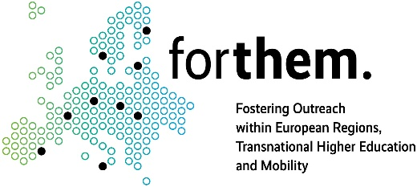

4th Annual FORTHEM conference
European Universities 2030: Building Knowledge Ecosystems for Europe’s Strategic Capacity in an Age of Polycrisis
June 3-5, 2026
ABSTRACT TEMPLATE
Title

Family name First name¹, Smith John^{,2}, …
¹Institution, e.g. University X, city, country [institution name in English as it appears on the official website]
²Institution, e.g. Hospital Y, city, country

Background. The analysed issue holds significant importance because….
Aim. The aim of the current study was…
word count not more than 400
Methods. 1000 responses to the survey were collected ….
Results. 50% (n=500) were considering the undertaken reforms a success ...
Conclusion. The approach taken ….
Acknowledgements. Disclosure of any conflict of interest, funding and other acknowledgements…

References: [1] …..(Times 11p, Italic)

Only one page, in English

