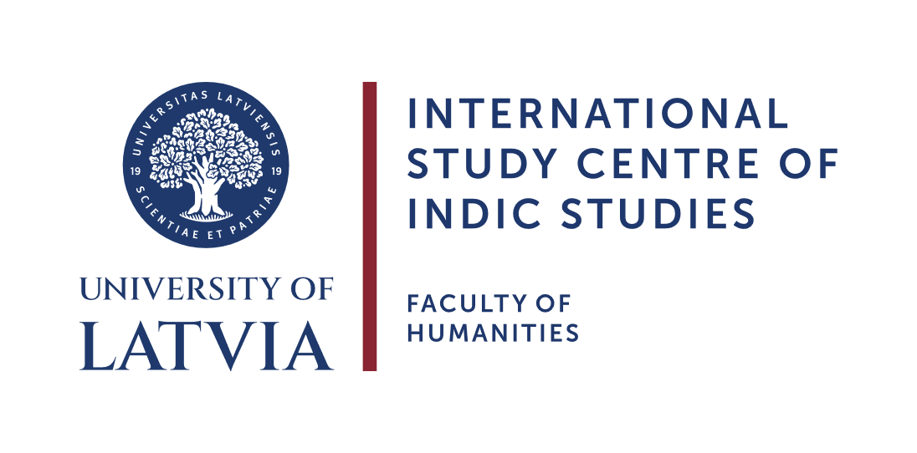
International Day of Yoga 2026
Scientific Conference
Rasa Dhvani: Emotional Intelligence, the Art of Yoga and Transformation
Venue: Auditorium Magnum, Dabas māja, Jelgavas iela 1, Rīga, Latvia + Online MsTeams
Date: 19th of June 2026, 10:30 EEST

PROGRAMME

Moderator: Prof. V. Pīrāgs

10:30 – 10:40 The opening address will be delivered by Her Excellency Ms. Namrata S. Kumar, Ambassador of the Republic of India to Latvia
10:40 – 11:00 Prof. Valdis Pīrāgs (Director, ICIS, University of Latvia). History of the International Day of Yoga celebration in Latvia.
11:00 – 11:35 Dr. Karl-Stéphan Bouthillette (Manipal Institute of Social Sciences, Humanities and Arts, India). Yoga as Philosophical Formation: Metaphysics, Therapy, and the Transformation of Consciousness
Modern discussions of yoga, if they engage philosophy at all, tend to regard it as a practical discipline supported by a philosophical framework. Many classical Indian traditions, however—particularly those I designate as “gnostic”— understood yoga in precisely the reverse way: as a process of philosophical formation in which insight into the nature of reality becomes a transformative and therapeutic practice in its own right. In a manner analogous to Abhinavagupta's understanding of aesthetic experience as capable of transforming the mode in which reality is received, these traditions regard philosophical insight not as information, but as a disciplined transformation of consciousness. Drawing on themes developed in Metaphysics as Therapy, this presentation examines yoga as a discipline of intellectual and existential cultivation whose goal is not merely physical fitness, emotional regulation, or psychological well-being, but liberation through a fundamental transformation of consciousness. In this sense, yoga emerges not as another philosophy of life, but as a way of living philosophically.
11:35 – 12:15 Dr. phil. Kaspars Eihmanis (Riga Nordic University). The Technologization of Cessation: Yoga as Self-Cancelling Cognitive Technology.
Modern vocabularies understand "cognitive technology" almost exclusively as external artifact: writing, computation, databases, models, instruments that augment cognition by offloading, extending, or optimizing it. This paper argues that these externalizing technologies are only one species of a wider genus. Human beings have also developed endogenous cognitive technologies, disciplined, transmitted, cumulatively refined techniques that work directly on attention, embodiment, and the structures of subjectivity, producing no external artifact. Yoga is the clearest and most philosophically important case.
12:15 – 12:55 Prof. Priyadarshi Patnaik (Professor of English and Communication at the Department of Humanities & Social Sciences and The Co-ordinator of Rekhi Centre of Excellence for the Science of Happiness, IIT Kharagpur, India). Rasa as Transformative Emotion: The Role of Sahṛdaya and the Aesthetic Training
This talk explores rasa first at the level of a theory that documents aesthetic experience insightfully. However, rasa theory goes beyond that, especially with the concept of Sahṛdaya (the sensitive audience). In Abhinavagupta’s thought, Sahṛdaya is a transformed experiencing entity. His/her transformation depends on the cultivated consciousness of the sahṛdaya, a mind reflects emotion without being bound by personal attachment, like a mirror. Such aesthetic training empties private emotion, universalizes affect, and offers a distinctive model of emotion regulation where art, feeling, and spiritual awareness converge.
12:55 – 13:20 Tea break

13:20 – 13:55 Dr. Shubham Kulkarni (MA In Ayurveda, PG Dip. in Palliative care, MA Psychology sch., Indian Classical Music Therapist, Indian classical Vocalist). Rasa-Dhvani and Nāda: Philosophical Foundations and Clinical Applications for Emotional Wellbeing.
The Indian concepts of Rasa, Dhvani, and Nāda provide a profound framework for understanding emotions, consciousness, and human transformation. While Rasa represents the refined experience of emotion, Dhvani conveys subtle resonance and meaning, and Nāda reflects the vibrational essence of sound and awareness. This presentation explores their philosophical foundations and their relevance to emotional wellbeing through the lenses of Yoga, Ayurveda, and Indian psychology. Drawing from clinical experiences in music therapy, mental health, and palliative care, it highlights how sound and aesthetic experience can support emotional awareness, resilience, healing, and inner balance in contemporary therapeutic settings.
13:55 – 14:30 Akash Sergejs Ancupovs (ICIS, University of Latvia). Mapping the Field of Transformation: Some Aspects of Terminological Differentiation — Puruṣa, Citta, Prakṛti, Rasa (Consciousness, Mind, Emotions).
By differentiating the roles of Puruṣa (Consciousness), Citta (Mind), Prakṛti (Matter), and Rasa (Emotion), this framework maps how all transformations occur strictly at the level of Prakṛti, spanning both its sūkṣma (subtle) and sthūla (gross) dimensions.
14:30 – 15:05 Arnis Siliņš, yoga educator, lecturer (ICIS, University of Latvia). Culturally Structured Knowledge: A Necessary Transition
This presentation examines the asymmetry between technological expansion and cultural integration, arguing that while technology enlarges the field of possible action, culturally structured knowledge is required to stabilize the field of meaningful action.
15:05 – 15:35 Panel Discussion

